**МІНІСТЕРСТВО ОСВІТИ І НАУКИ, МОЛОДІ ТА СПОРТУ УКРАЇНИ**

**НАЦІОНАЛЬНИЙ ТЕХНІЧНИЙ УНІВЕРСИТЕТ УКРАЇНИ**

**«КИЇВСЬКИЙ ПОЛІТЕХНІЧНИЙ ІНСТИТУТ»**

Навчально-науковий комплекс

«Інститут прикладного системного аналізу»

**Кафедра системного проектування**

Лабораторна робота № 2

з курсу «Інтелектуальний аналіз даних»

«Знайомство з алгоритмами класифікації даних»

Варіант 1

Виконала :

студентка групи ДА-42

Балан Катерина

Київ 2017

**Мета роботи:** Ознайомитися та отримати навички побудови моделей кластеризації за допомогою Data Mining GUI бібліотеки WEKA.

**Завдання:** Побудувати модель кластеризації за допомогою алгоритму кластеризації.

Метод кластеризації використовує відомі дані для аналізу зв'язків значень атрибутів.

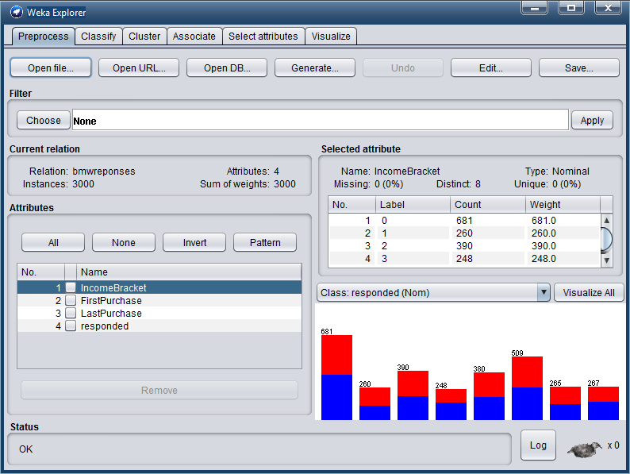

=== Run information ===

Scheme: weka.classifiers.trees.REPTree -M 2 -V 0.001 -N 3 -S 1 -L -1 -I 0.0

Relation: bmwreponses

Instances: 3000

Attributes: 4

IncomeBracket

FirstPurchase

LastPurchase

responded

Test mode: evaluate on training data

=== Classifier model (full training set) ===

REPTree

============

LastPurchase < 200504.5

| IncomeBracket = 0 : 0 (9/2) [6/2]

| IncomeBracket = 1 : 0 (7/1) [1/0]

| IncomeBracket = 2 : 0 (10/3) [3/1]

| IncomeBracket = 3

| | FirstPurchase < 199711 : 1 (2/0) [2/0]

| | FirstPurchase >= 199711 : 0 (6/1) [5/1]

| IncomeBracket = 4 : 0 (8/1) [3/2]

| IncomeBracket = 5 : 0 (14/4) [3/0]

| IncomeBracket = 6

| | FirstPurchase < 199853 : 0 (2/0) [0/0]

| | FirstPurchase >= 199853 : 1 (4/2) [4/1]

| IncomeBracket = 7

| | FirstPurchase < 200156 : 0 (3/0) [1/1]

| | FirstPurchase >= 200156 : 1 (5/2) [4/1]

LastPurchase >= 200504.5

| FirstPurchase < 200011.5

| | IncomeBracket = 0

| | | FirstPurchase < 199810.5

| | | | FirstPurchase < 199808

| | | | | FirstPurchase < 199606.5 : 1 (3/0) [1/0]

| | | | | FirstPurchase >= 199606.5

| | | | | | LastPurchase < 200656

| | | | | | | FirstPurchase < 199703.5

| | | | | | | | FirstPurchase < 199656.5 : 1 (44/20) [12/4]

| | | | | | | | FirstPurchase >= 199656.5 : 0 (12/3) [8/3]

| | | | | | | FirstPurchase >= 199703.5

| | | | | | | | LastPurchase < 200507 : 1 (2/0) [2/1]

| | | | | | | | LastPurchase >= 200507

| | | | | | | | | LastPurchase < 200610

| | | | | | | | | | LastPurchase < 200602.5 : 1 (32/10) [13/4]

| | | | | | | | | | LastPurchase >= 200602.5 : 0 (10/4) [4/1]

| | | | | | | | | LastPurchase >= 200610 : 1 (2/0) [0/0]

| | | | | | LastPurchase >= 200656 : 0 (2/0) [0/0]

| | | | FirstPurchase >= 199808 : 0 (11/2) [0/0]

| | | FirstPurchase >= 199810.5 : 1 (76/22) [31/14]

| | IncomeBracket = 1

| | | LastPurchase < 200656.5

| | | | FirstPurchase < 199810.5

| | | | | FirstPurchase < 199756.5

| | | | | | FirstPurchase < 199705.5

| | | | | | | LastPurchase < 200510.5

| | | | | | | | LastPurchase < 200507.5 : 1 (6/3) [1/0]

| | | | | | | | LastPurchase >= 200507.5 : 0 (5/0) [2/0]

| | | | | | | LastPurchase >= 200510.5 : 1 (29/16) [15/5]

| | | | | | FirstPurchase >= 199705.5

| | | | | | | LastPurchase < 200556.5

| | | | | | | | FirstPurchase < 199706.5 : 1 (2/1) [1/0]

| | | | | | | | FirstPurchase >= 199706.5 : 0 (2/0) [1/0]

| | | | | | | LastPurchase >= 200556.5 : 1 (5/0) [3/1]

| | | | | FirstPurchase >= 199756.5 : 0 (12/2) [8/2]

| | | | FirstPurchase >= 199810.5

| | | | | FirstPurchase < 199908 : 1 (8/1) [1/1]

| | | | | FirstPurchase >= 199908 : 0 (13/5) [15/5]

| | | LastPurchase >= 200656.5 : 1 (3/0) [2/0]

| | IncomeBracket = 2 : 1 (120/57) [66/23]

| | IncomeBracket = 3 : 1 (67/21) [33/12]

| | IncomeBracket = 4

| | | FirstPurchase < 199901.5

| | | | LastPurchase < 200511.5

| | | | | LastPurchase < 200509.5 : 0 (9/1) [3/1]

| | | | | LastPurchase >= 200509.5

| | | | | | FirstPurchase < 199655.5 : 1 (3/1) [3/1]

| | | | | | FirstPurchase >= 199655.5 : 0 (6/1) [2/0]

| | | | LastPurchase >= 200511.5 : 1 (42/19) [23/8]

| | | FirstPurchase >= 199901.5 : 1 (46/15) [17/8]

| | IncomeBracket = 5

| | | LastPurchase < 200656.5

| | | | LastPurchase < 200610.5

| | | | | FirstPurchase < 200001.5

| | | | | | FirstPurchase < 199910.5

| | | | | | | FirstPurchase < 199810.5

| | | | | | | | FirstPurchase < 199708 : 1 (52/22) [21/7]

| | | | | | | | FirstPurchase >= 199708

| | | | | | | | | FirstPurchase < 199756.5 : 0 (3/0) [1/1]

| | | | | | | | | FirstPurchase >= 199756.5

| | | | | | | | | | LastPurchase < 200511.5 : 0 (7/1) [3/0]

| | | | | | | | | | LastPurchase >= 200511.5 : 1 (15/6) [12/4]

| | | | | | | FirstPurchase >= 199810.5 : 1 (17/5) [6/3]

| | | | | | FirstPurchase >= 199910.5 : 0 (8/2) [6/1]

| | | | | FirstPurchase >= 200001.5 : 1 (24/8) [8/0]

| | | | LastPurchase >= 200610.5 : 0 (3/0) [0/0]

| | | LastPurchase >= 200656.5 : 1 (2/0) [2/0]

| | IncomeBracket = 6

| | | LastPurchase < 200507.5 : 0 (7/1) [3/0]

| | | LastPurchase >= 200507.5 : 1 (69/28) [38/15]

| | IncomeBracket = 7 : 1 (67/21) [45/17]

| FirstPurchase >= 200011.5

| | IncomeBracket = 0

| | | LastPurchase < 200607

| | | | FirstPurchase < 200409.5 : 1 (175/84) [85/34]

| | | | FirstPurchase >= 200409.5

| | | | | LastPurchase < 200511.5 : 0 (34/6) [19/8]

| | | | | LastPurchase >= 200511.5

| | | | | | FirstPurchase < 200601.5

| | | | | | | LastPurchase < 200602.5

| | | | | | | | FirstPurchase < 200509.5

| | | | | | | | | FirstPurchase < 200506.5

| | | | | | | | | | FirstPurchase < 200504

| | | | | | | | | | | LastPurchase < 200601.5 : 0 (18/7) [6/1]

| | | | | | | | | | | LastPurchase >= 200601.5 : 1 (3/1) [6/2]

| | | | | | | | | | FirstPurchase >= 200504 : 1 (4/1) [0/0]

| | | | | | | | | FirstPurchase >= 200506.5 : 0 (5/1) [1/0]

| | | | | | | | FirstPurchase >= 200509.5 : 1 (10/4) [3/1]

| | | | | | | LastPurchase >= 200602.5 : 1 (11/4) [6/3]

| | | | | | FirstPurchase >= 200601.5 : 0 (6/1) [2/0]

| | | LastPurchase >= 200607 : 1 (5/0) [2/0]

| | IncomeBracket = 1 : 0 (80/34) [38/17]

| | IncomeBracket = 2

| | | LastPurchase < 200509.5

| | | | FirstPurchase < 200104.5 : 0 (2/0) [2/0]

| | | | FirstPurchase >= 200104.5

| | | | | FirstPurchase < 200201.5 : 1 (3/0) [1/0]

| | | | | FirstPurchase >= 200201.5

| | | | | | FirstPurchase < 200252.5 : 0 (2/0) [1/0]

| | | | | | FirstPurchase >= 200252.5 : 1 (17/4) [12/9]

| | | LastPurchase >= 200509.5

| | | | FirstPurchase < 200556.5

| | | | | FirstPurchase < 200405

| | | | | | FirstPurchase < 200402.5 : 0 (55/22) [23/5]

| | | | | | FirstPurchase >= 200402.5 : 1 (2/0) [1/0]

| | | | | FirstPurchase >= 200405

| | | | | | LastPurchase < 200601.5

| | | | | | | FirstPurchase < 200408 : 0 (2/0) [2/0]

| | | | | | | FirstPurchase >= 200408

| | | | | | | | LastPurchase < 200511.5 : 0 (8/2) [5/1]

| | | | | | | | LastPurchase >= 200511.5 : 1 (11/5) [13/4]

| | | | | | LastPurchase >= 200601.5 : 0 (12/1) [5/2]

| | | | FirstPurchase >= 200556.5 : 1 (9/3) [3/1]

| | IncomeBracket = 3

| | | FirstPurchase < 200408

| | | | FirstPurchase < 200355.5

| | | | | LastPurchase < 200601.5 : 0 (29/12) [9/2]

| | | | | LastPurchase >= 200601.5 : 1 (13/3) [5/3]

| | | | FirstPurchase >= 200355.5 : 1 (21/3) [3/2]

| | | FirstPurchase >= 200408 : 0 (37/15) [16/8]

| | IncomeBracket = 4

| | | FirstPurchase < 200156 : 0 (16/2) [9/4]

| | | FirstPurchase >= 200156

| | | | FirstPurchase < 200507.5

| | | | | FirstPurchase < 200411 : 0 (66/30) [37/14]

| | | | | FirstPurchase >= 200411 : 1 (34/7) [16/7]

| | | | FirstPurchase >= 200507.5 : 0 (17/5) [20/6]

| | IncomeBracket = 5

| | | FirstPurchase < 200556.5

| | | | LastPurchase < 200505.5 : 0 (2/0) [4/0]

| | | | LastPurchase >= 200505.5

| | | | | FirstPurchase < 200302.5

| | | | | | FirstPurchase < 200204 : 1 (44/21) [27/13]

| | | | | | FirstPurchase >= 200204 : 0 (25/6) [14/5]

| | | | | FirstPurchase >= 200302.5

| | | | | | LastPurchase < 200602.5

| | | | | | | FirstPurchase < 200310.5 : 1 (17/5) [9/5]

| | | | | | | FirstPurchase >= 200310.5

| | | | | | | | FirstPurchase < 200410.5 : 0 (42/16) [17/7]

| | | | | | | | FirstPurchase >= 200410.5 : 1 (35/16) [19/8]

| | | | | | LastPurchase >= 200602.5 : 1 (15/4) [11/5]

| | | FirstPurchase >= 200556.5 : 1 (12/2) [9/5]

| | IncomeBracket = 6 : 0 (84/33) [54/23]

| | IncomeBracket = 7

| | | LastPurchase < 200655.5

| | | | LastPurchase < 200607.5

| | | | | FirstPurchase < 200509.5

| | | | | | FirstPurchase < 200101.5 : 0 (5/1) [2/0]

| | | | | | FirstPurchase >= 200101.5

| | | | | | | FirstPurchase < 200106.5 : 1 (8/1) [3/0]

| | | | | | | FirstPurchase >= 200106.5

| | | | | | | | FirstPurchase < 200110.5 : 0 (4/0) [0/0]

| | | | | | | | FirstPurchase >= 200110.5

| | | | | | | | | LastPurchase < 200602.5

| | | | | | | | | | FirstPurchase < 200156 : 1 (2/0) [0/0]

| | | | | | | | | | FirstPurchase >= 200156

| | | | | | | | | | | FirstPurchase < 200203.5

| | | | | | | | | | | | FirstPurchase < 200201.5 : 1 (5/2) [1/0]

| | | | | | | | | | | | FirstPurchase >= 200201.5 : 0 (4/0) [1/0]

| | | | | | | | | | | FirstPurchase >= 200203.5

| | | | | | | | | | | | FirstPurchase < 200209.5 : 1 (3/0) [0/0]

| | | | | | | | | | | | FirstPurchase >= 200209.5

| | | | | | | | | | | | | LastPurchase < 200601.5

| | | | | | | | | | | | | | LastPurchase < 200556.5

| | | | | | | | | | | | | | | LastPurchase < 200509.5

| | | | | | | | | | | | | | | | FirstPurchase < 200455.5 : 0 (6/1) [3/2]

| | | | | | | | | | | | | | | | FirstPurchase >= 200455.5

| | | | | | | | | | | | | | | | | FirstPurchase < 200508.5 : 1 (6/1) [4/1]

| | | | | | | | | | | | | | | | | FirstPurchase >= 200508.5 : 0 (3/1) [1/0]

| | | | | | | | | | | | | | | LastPurchase >= 200509.5

| | | | | | | | | | | | | | | | FirstPurchase < 200256 : 0 (3/1) [2/0]

| | | | | | | | | | | | | | | | FirstPurchase >= 200256 : 1 (13/4) [7/2]

| | | | | | | | | | | | | | LastPurchase >= 200556.5 : 0 (2/0) [4/2]

| | | | | | | | | | | | | LastPurchase >= 200601.5 : 1 (7/1) [3/1]

| | | | | | | | | LastPurchase >= 200602.5 : 0 (10/3) [4/1]

| | | | | FirstPurchase >= 200509.5 : 0 (14/4) [5/0]

| | | | LastPurchase >= 200607.5 : 1 (3/0) [0/0]

| | | LastPurchase >= 200655.5 : 0 (3/0) [1/0]

Size of the tree : 195

Time taken to build model: 0.05 seconds

=== Evaluation on training set ===

Time taken to test model on training data: 0.08 seconds

=== Summary ===

Correctly Classified Instances 1941 64.7 %

Incorrectly Classified Instances 1059 35.3 %

Kappa statistic 0.2912

Mean absolute error 0.4357

Root mean squared error 0.4668

Relative absolute error 87.1679 %

Root relative squared error 93.3638 %

Total Number of Instances 3000

=== Detailed Accuracy By Class ===

TP Rate FP Rate Precision Recall F-Measure MCC ROC Area PRC Area Class

0,759 0,469 0,626 0,759 0,686 0,298 0,697 0,685 1

0,531 0,241 0,681 0,531 0,597 0,298 0,697 0,696 0

Weighted Avg. 0,647 0,357 0,653 0,647 0,642 0,298 0,697 0,691

=== Confusion Matrix ===

a b <-- classified as

1158 367 | a = 1

692 783 | b = 0

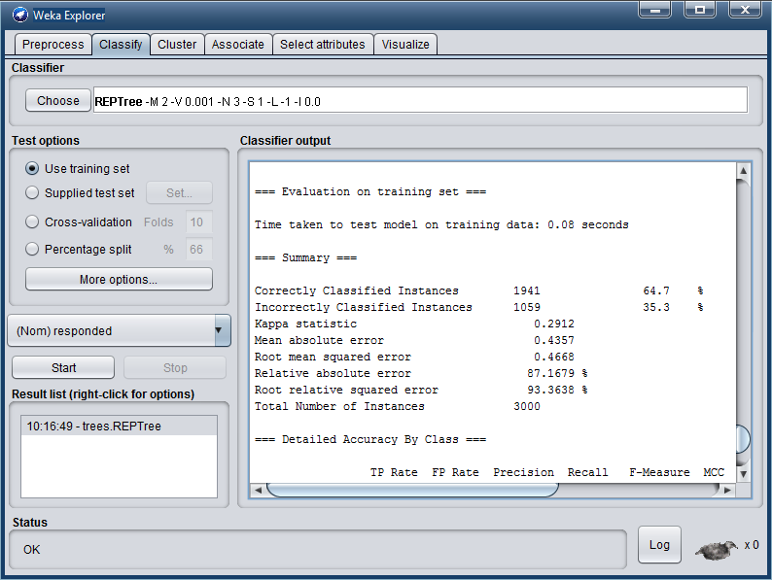

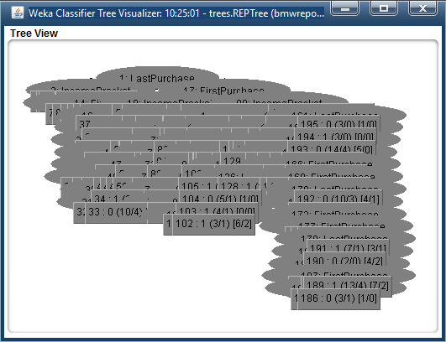

=== Run information ===

Scheme: weka.classifiers.trees.REPTree -M 2 -V 0.001 -N 3 -S 1 -L -1 -I 0.0

Relation: bmwreponses

Instances: 3000

Attributes: 4

IncomeBracket

FirstPurchase

LastPurchase

responded

Test mode: user supplied test set: size unknown (reading incrementally)

=== Classifier model (full training set) ===

REPTree

============

LastPurchase < 200504.5

| IncomeBracket = 0 : 0 (9/2) [6/2]

| IncomeBracket = 1 : 0 (7/1) [1/0]

| IncomeBracket = 2 : 0 (10/3) [3/1]

| IncomeBracket = 3

| | FirstPurchase < 199711 : 1 (2/0) [2/0]

| | FirstPurchase >= 199711 : 0 (6/1) [5/1]

| IncomeBracket = 4 : 0 (8/1) [3/2]

| IncomeBracket = 5 : 0 (14/4) [3/0]

| IncomeBracket = 6

| | FirstPurchase < 199853 : 0 (2/0) [0/0]

| | FirstPurchase >= 199853 : 1 (4/2) [4/1]

| IncomeBracket = 7

| | FirstPurchase < 200156 : 0 (3/0) [1/1]

| | FirstPurchase >= 200156 : 1 (5/2) [4/1]

LastPurchase >= 200504.5

| FirstPurchase < 200011.5

| | IncomeBracket = 0

| | | FirstPurchase < 199810.5

| | | | FirstPurchase < 199808

| | | | | FirstPurchase < 199606.5 : 1 (3/0) [1/0]

| | | | | FirstPurchase >= 199606.5

| | | | | | LastPurchase < 200656

| | | | | | | FirstPurchase < 199703.5

| | | | | | | | FirstPurchase < 199656.5 : 1 (44/20) [12/4]

| | | | | | | | FirstPurchase >= 199656.5 : 0 (12/3) [8/3]

| | | | | | | FirstPurchase >= 199703.5

| | | | | | | | LastPurchase < 200507 : 1 (2/0) [2/1]

| | | | | | | | LastPurchase >= 200507

| | | | | | | | | LastPurchase < 200610

| | | | | | | | | | LastPurchase < 200602.5 : 1 (32/10) [13/4]

| | | | | | | | | | LastPurchase >= 200602.5 : 0 (10/4) [4/1]

| | | | | | | | | LastPurchase >= 200610 : 1 (2/0) [0/0]

| | | | | | LastPurchase >= 200656 : 0 (2/0) [0/0]

| | | | FirstPurchase >= 199808 : 0 (11/2) [0/0]

| | | FirstPurchase >= 199810.5 : 1 (76/22) [31/14]

| | IncomeBracket = 1

| | | LastPurchase < 200656.5

| | | | FirstPurchase < 199810.5

| | | | | FirstPurchase < 199756.5

| | | | | | FirstPurchase < 199705.5

| | | | | | | LastPurchase < 200510.5

| | | | | | | | LastPurchase < 200507.5 : 1 (6/3) [1/0]

| | | | | | | | LastPurchase >= 200507.5 : 0 (5/0) [2/0]

| | | | | | | LastPurchase >= 200510.5 : 1 (29/16) [15/5]

| | | | | | FirstPurchase >= 199705.5

| | | | | | | LastPurchase < 200556.5

| | | | | | | | FirstPurchase < 199706.5 : 1 (2/1) [1/0]

| | | | | | | | FirstPurchase >= 199706.5 : 0 (2/0) [1/0]

| | | | | | | LastPurchase >= 200556.5 : 1 (5/0) [3/1]

| | | | | FirstPurchase >= 199756.5 : 0 (12/2) [8/2]

| | | | FirstPurchase >= 199810.5

| | | | | FirstPurchase < 199908 : 1 (8/1) [1/1]

| | | | | FirstPurchase >= 199908 : 0 (13/5) [15/5]

| | | LastPurchase >= 200656.5 : 1 (3/0) [2/0]

| | IncomeBracket = 2 : 1 (120/57) [66/23]

| | IncomeBracket = 3 : 1 (67/21) [33/12]

| | IncomeBracket = 4

| | | FirstPurchase < 199901.5

| | | | LastPurchase < 200511.5

| | | | | LastPurchase < 200509.5 : 0 (9/1) [3/1]

| | | | | LastPurchase >= 200509.5

| | | | | | FirstPurchase < 199655.5 : 1 (3/1) [3/1]

| | | | | | FirstPurchase >= 199655.5 : 0 (6/1) [2/0]

| | | | LastPurchase >= 200511.5 : 1 (42/19) [23/8]

| | | FirstPurchase >= 199901.5 : 1 (46/15) [17/8]

| | IncomeBracket = 5

| | | LastPurchase < 200656.5

| | | | LastPurchase < 200610.5

| | | | | FirstPurchase < 200001.5

| | | | | | FirstPurchase < 199910.5

| | | | | | | FirstPurchase < 199810.5

| | | | | | | | FirstPurchase < 199708 : 1 (52/22) [21/7]

| | | | | | | | FirstPurchase >= 199708

| | | | | | | | | FirstPurchase < 199756.5 : 0 (3/0) [1/1]

| | | | | | | | | FirstPurchase >= 199756.5

| | | | | | | | | | LastPurchase < 200511.5 : 0 (7/1) [3/0]

| | | | | | | | | | LastPurchase >= 200511.5 : 1 (15/6) [12/4]

| | | | | | | FirstPurchase >= 199810.5 : 1 (17/5) [6/3]

| | | | | | FirstPurchase >= 199910.5 : 0 (8/2) [6/1]

| | | | | FirstPurchase >= 200001.5 : 1 (24/8) [8/0]

| | | | LastPurchase >= 200610.5 : 0 (3/0) [0/0]

| | | LastPurchase >= 200656.5 : 1 (2/0) [2/0]

| | IncomeBracket = 6

| | | LastPurchase < 200507.5 : 0 (7/1) [3/0]

| | | LastPurchase >= 200507.5 : 1 (69/28) [38/15]

| | IncomeBracket = 7 : 1 (67/21) [45/17]

| FirstPurchase >= 200011.5

| | IncomeBracket = 0

| | | LastPurchase < 200607

| | | | FirstPurchase < 200409.5 : 1 (175/84) [85/34]

| | | | FirstPurchase >= 200409.5

| | | | | LastPurchase < 200511.5 : 0 (34/6) [19/8]

| | | | | LastPurchase >= 200511.5

| | | | | | FirstPurchase < 200601.5

| | | | | | | LastPurchase < 200602.5

| | | | | | | | FirstPurchase < 200509.5

| | | | | | | | | FirstPurchase < 200506.5

| | | | | | | | | | FirstPurchase < 200504

| | | | | | | | | | | LastPurchase < 200601.5 : 0 (18/7) [6/1]

| | | | | | | | | | | LastPurchase >= 200601.5 : 1 (3/1) [6/2]

| | | | | | | | | | FirstPurchase >= 200504 : 1 (4/1) [0/0]

| | | | | | | | | FirstPurchase >= 200506.5 : 0 (5/1) [1/0]

| | | | | | | | FirstPurchase >= 200509.5 : 1 (10/4) [3/1]

| | | | | | | LastPurchase >= 200602.5 : 1 (11/4) [6/3]

| | | | | | FirstPurchase >= 200601.5 : 0 (6/1) [2/0]

| | | LastPurchase >= 200607 : 1 (5/0) [2/0]

| | IncomeBracket = 1 : 0 (80/34) [38/17]

| | IncomeBracket = 2

| | | LastPurchase < 200509.5

| | | | FirstPurchase < 200104.5 : 0 (2/0) [2/0]

| | | | FirstPurchase >= 200104.5

| | | | | FirstPurchase < 200201.5 : 1 (3/0) [1/0]

| | | | | FirstPurchase >= 200201.5

| | | | | | FirstPurchase < 200252.5 : 0 (2/0) [1/0]

| | | | | | FirstPurchase >= 200252.5 : 1 (17/4) [12/9]

| | | LastPurchase >= 200509.5

| | | | FirstPurchase < 200556.5

| | | | | FirstPurchase < 200405

| | | | | | FirstPurchase < 200402.5 : 0 (55/22) [23/5]

| | | | | | FirstPurchase >= 200402.5 : 1 (2/0) [1/0]

| | | | | FirstPurchase >= 200405

| | | | | | LastPurchase < 200601.5

| | | | | | | FirstPurchase < 200408 : 0 (2/0) [2/0]

| | | | | | | FirstPurchase >= 200408

| | | | | | | | LastPurchase < 200511.5 : 0 (8/2) [5/1]

| | | | | | | | LastPurchase >= 200511.5 : 1 (11/5) [13/4]

| | | | | | LastPurchase >= 200601.5 : 0 (12/1) [5/2]

| | | | FirstPurchase >= 200556.5 : 1 (9/3) [3/1]

| | IncomeBracket = 3

| | | FirstPurchase < 200408

| | | | FirstPurchase < 200355.5

| | | | | LastPurchase < 200601.5 : 0 (29/12) [9/2]

| | | | | LastPurchase >= 200601.5 : 1 (13/3) [5/3]

| | | | FirstPurchase >= 200355.5 : 1 (21/3) [3/2]

| | | FirstPurchase >= 200408 : 0 (37/15) [16/8]

| | IncomeBracket = 4

| | | FirstPurchase < 200156 : 0 (16/2) [9/4]

| | | FirstPurchase >= 200156

| | | | FirstPurchase < 200507.5

| | | | | FirstPurchase < 200411 : 0 (66/30) [37/14]

| | | | | FirstPurchase >= 200411 : 1 (34/7) [16/7]

| | | | FirstPurchase >= 200507.5 : 0 (17/5) [20/6]

| | IncomeBracket = 5

| | | FirstPurchase < 200556.5

| | | | LastPurchase < 200505.5 : 0 (2/0) [4/0]

| | | | LastPurchase >= 200505.5

| | | | | FirstPurchase < 200302.5

| | | | | | FirstPurchase < 200204 : 1 (44/21) [27/13]

| | | | | | FirstPurchase >= 200204 : 0 (25/6) [14/5]

| | | | | FirstPurchase >= 200302.5

| | | | | | LastPurchase < 200602.5

| | | | | | | FirstPurchase < 200310.5 : 1 (17/5) [9/5]

| | | | | | | FirstPurchase >= 200310.5

| | | | | | | | FirstPurchase < 200410.5 : 0 (42/16) [17/7]

| | | | | | | | FirstPurchase >= 200410.5 : 1 (35/16) [19/8]

| | | | | | LastPurchase >= 200602.5 : 1 (15/4) [11/5]

| | | FirstPurchase >= 200556.5 : 1 (12/2) [9/5]

| | IncomeBracket = 6 : 0 (84/33) [54/23]

| | IncomeBracket = 7

| | | LastPurchase < 200655.5

| | | | LastPurchase < 200607.5

| | | | | FirstPurchase < 200509.5

| | | | | | FirstPurchase < 200101.5 : 0 (5/1) [2/0]

| | | | | | FirstPurchase >= 200101.5

| | | | | | | FirstPurchase < 200106.5 : 1 (8/1) [3/0]

| | | | | | | FirstPurchase >= 200106.5

| | | | | | | | FirstPurchase < 200110.5 : 0 (4/0) [0/0]

| | | | | | | | FirstPurchase >= 200110.5

| | | | | | | | | LastPurchase < 200602.5

| | | | | | | | | | FirstPurchase < 200156 : 1 (2/0) [0/0]

| | | | | | | | | | FirstPurchase >= 200156

| | | | | | | | | | | FirstPurchase < 200203.5

| | | | | | | | | | | | FirstPurchase < 200201.5 : 1 (5/2) [1/0]

| | | | | | | | | | | | FirstPurchase >= 200201.5 : 0 (4/0) [1/0]

| | | | | | | | | | | FirstPurchase >= 200203.5

| | | | | | | | | | | | FirstPurchase < 200209.5 : 1 (3/0) [0/0]

| | | | | | | | | | | | FirstPurchase >= 200209.5

| | | | | | | | | | | | | LastPurchase < 200601.5

| | | | | | | | | | | | | | LastPurchase < 200556.5

| | | | | | | | | | | | | | | LastPurchase < 200509.5

| | | | | | | | | | | | | | | | FirstPurchase < 200455.5 : 0 (6/1) [3/2]

| | | | | | | | | | | | | | | | FirstPurchase >= 200455.5

| | | | | | | | | | | | | | | | | FirstPurchase < 200508.5 : 1 (6/1) [4/1]

| | | | | | | | | | | | | | | | | FirstPurchase >= 200508.5 : 0 (3/1) [1/0]

| | | | | | | | | | | | | | | LastPurchase >= 200509.5

| | | | | | | | | | | | | | | | FirstPurchase < 200256 : 0 (3/1) [2/0]

| | | | | | | | | | | | | | | | FirstPurchase >= 200256 : 1 (13/4) [7/2]

| | | | | | | | | | | | | | LastPurchase >= 200556.5 : 0 (2/0) [4/2]

| | | | | | | | | | | | | LastPurchase >= 200601.5 : 1 (7/1) [3/1]

| | | | | | | | | LastPurchase >= 200602.5 : 0 (10/3) [4/1]

| | | | | FirstPurchase >= 200509.5 : 0 (14/4) [5/0]

| | | | LastPurchase >= 200607.5 : 1 (3/0) [0/0]

| | | LastPurchase >= 200655.5 : 0 (3/0) [1/0]

Size of the tree : 195

Time taken to build model: 0.03 seconds

=== Evaluation on test set ===

Time taken to test model on supplied test set: 0.03 seconds

=== Summary ===

Correctly Classified Instances 846 56.4 %

Incorrectly Classified Instances 654 43.6 %

Kappa statistic 0.1307

Mean absolute error 0.4743

Root mean squared error 0.5073

Relative absolute error 94.8365 %

Root relative squared error 101.4211 %

Total Number of Instances 1500

=== Detailed Accuracy By Class ===

TP Rate FP Rate Precision Recall F-Measure MCC ROC Area PRC Area Class

0,645 0,514 0,547 0,645 0,592 0,133 0,581 0,562 1

0,486 0,355 0,588 0,486 0,532 0,133 0,581 0,569 0

Weighted Avg. 0,564 0,433 0,568 0,564 0,561 0,133 0,581 0,566

=== Confusion Matrix ===

a b <-- classified as

474 261 | a = 1

393 372 | b = 0

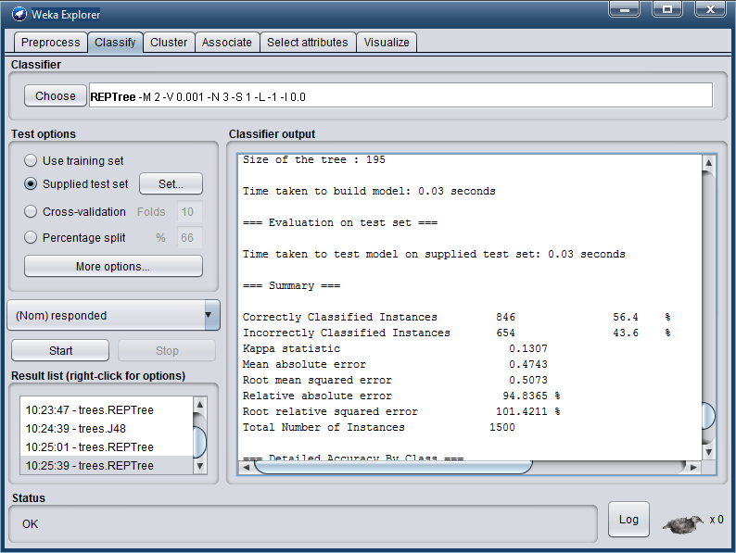

**Висновок**. Під час виконання лабораторної роботи було ознайомлено та отримано навички побудови моделей класифікаторів за допомогою Data Mining GUI бібліотеки WEKA і зроблений аналіз зв'язків значень атрибутів persons i buying. Для збільшення точності треба більше навчальних атрибутів.